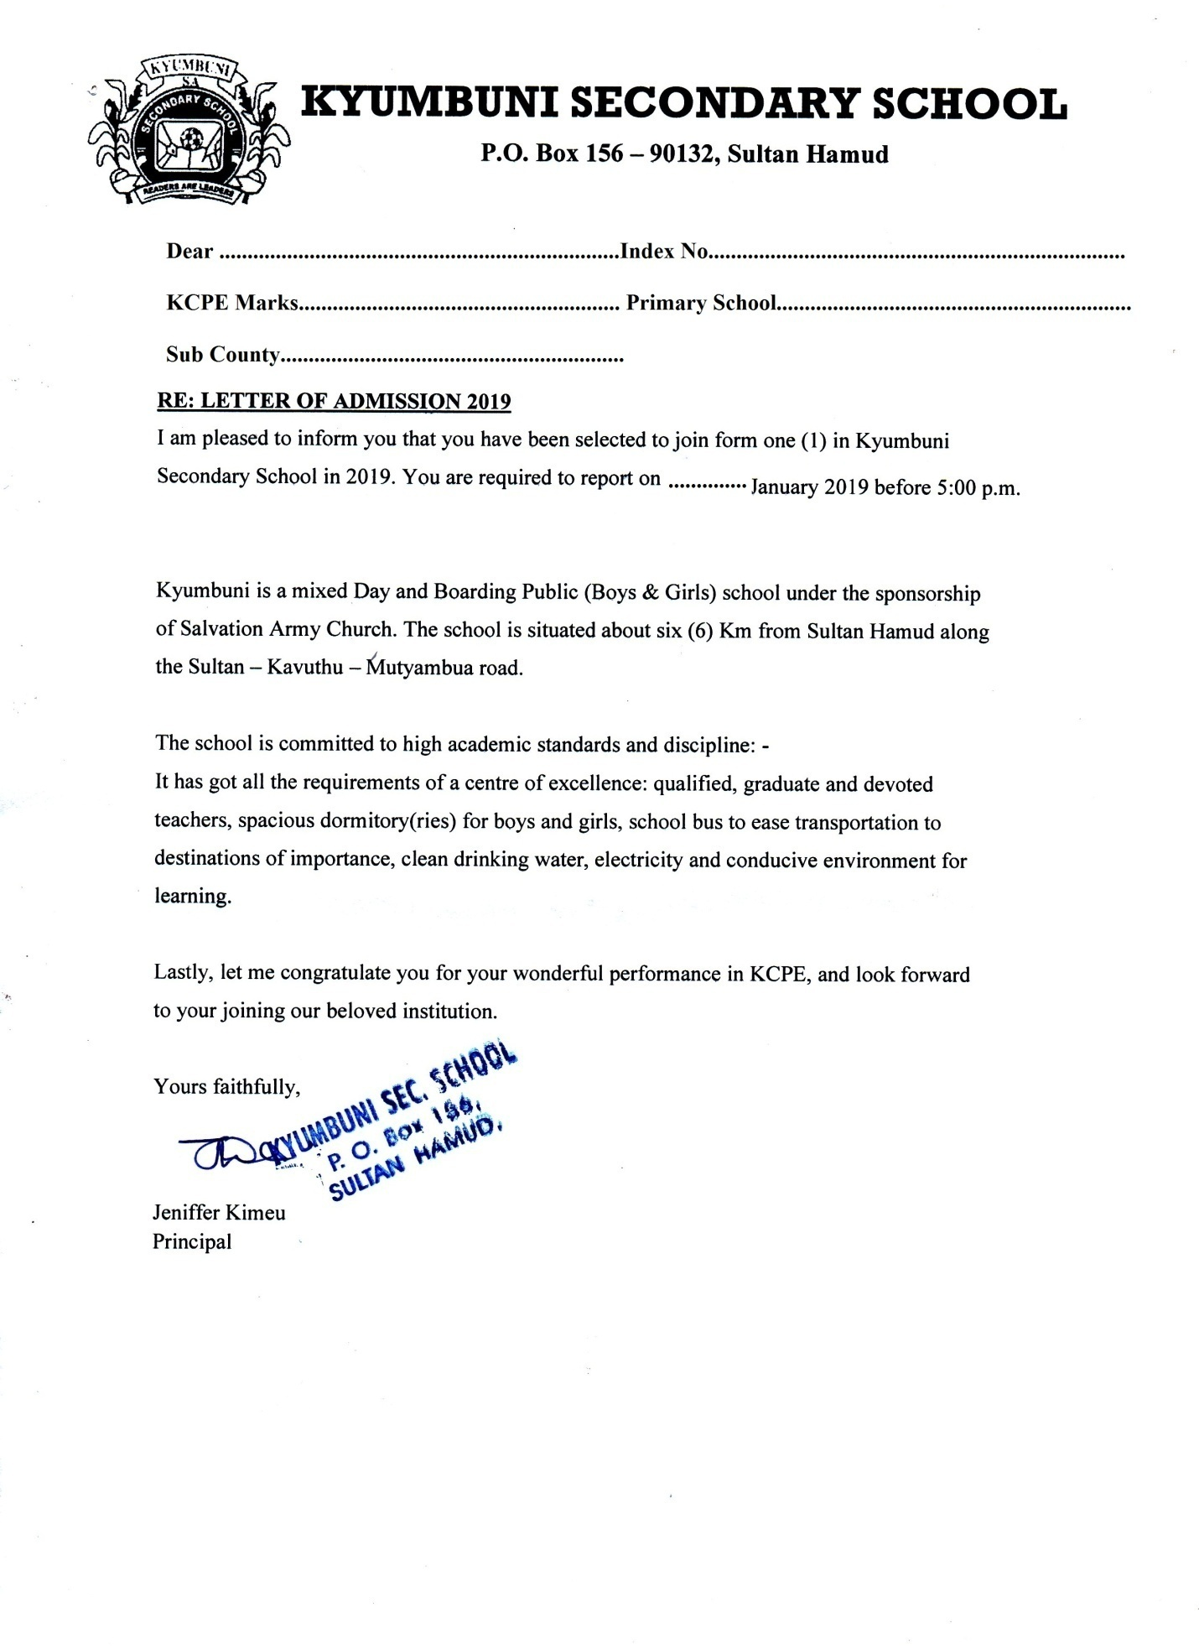 **KYUMBUNI SECONDARY SCHOOL**

**P.O BOX 156-90132, SULTAN HAMUD**

**0708161650**

**Email:** [**kyumbunischool@gmail.com**](mailto:kyumbunischool@gmail.com)

**SCHOOL MOTTO: READERS ARE LEADERS**

**___________________________________________________________________________**

**YEAR 2024**

Dear: (………………………………………………)

I am pleased to inform you that you have been selected to join our school, congratulations.

You are expected to report on ……………….

**Please get your primary school’s Head teacher to endorse the letter in the spaces provided below.**

Students full name: (…………………………………………………………………….……) Index no: (……………………………………) marks (…………………...)

Sub-county (……………………………...……)

Primary school: ________________________________________________________________

Head teacher’s Full Name: ________________________________________________________

Head teacher Signature: ___________________ Date: ______________

Student’s Signature: ______________________ Date: _____________

**Disclaimer: this letter will be authenticated in being duly certified by the primary school head complete with a certified copy of birth certificate and finally confirmed by the admitting principal. The letter is issued without any erasure or alteration and cannot be changed through any form of endorsement whatsoever; utterance of false documents is an offence punishable by law.**

**KYUMBUNI SECONDARY SCHOOL**

**P.O BOX 156-90132**

**SULTAN HAMUD**

**SCHOOL MOTTO: READERS ARE LEADERS**

**FEES STRUCTURE FORM ONE 2024 BOARDERS**

|  |  |  |  |  |  |  |  |  |
| --- | --- | --- | --- | --- | --- | --- | --- | --- |
| **VOTE HEAD** | **TERM 1** | | **TERM 11** | | **TERM 111** | | **TOTAL** | |
|  | **Kshs** | **Cts** | **Kshs** | **Cts** | **Kshs** | **Cts** | **Kshs** | **Cts** |
| Boarding equipment& store / lunch | 11,625 | 00 | 6,975 | 00 | 4,650 | 00 | 23,250 | 00 |
| Repair, maintenance & improvement (RMI) | 1,200 | 00 | 720 | 00 | 480 | 00 | 2,400 | 00 |
| Local travel & Transport (LT&T) | 325 | 00 | 195 | 00 | 130 | 00 | 650 | 00 |
| Electricity, water & conservancy(E.W.C) | 2,450 | 00 | 1,470 | 00 | 680 | 00 | 4,900 | 00 |
| Administrative costs | 925 | 00 | 555 | 00 | 370 | 00 | 1,850 | 00 |
| Medical & Insurance | 00 | 00 | 00 | 00 | 00 | 00 | 00 | 00 |
| Personal emoluments | 1,550 | 00 | 930 | 00 | 920 | 00 | 3,100 | 00 |
| Activity | 75 | 00 | 45 | 00 | 30 | 00 | 150 | 00 |
| **TOTAL** | 18,150 | 00 | 10,890 | 00 | 7,260 | 00 | 36,300 | 00 |

**DAYSCHOLARS**

|  |  |  |  |  |  |  |  |  |
| --- | --- | --- | --- | --- | --- | --- | --- | --- |
| VOTEHEAD | TERM I | | TERM II | | TERM III | | TOTAL | |
|  | KSH | CTS | KSH | CTS | KSH | CTS | KSH | CTS |
|  | 4000 | 00 | 4000 | 00 | 4000 | 00 | 12000 | 00 |
| TOTAL | 4000 | 00 | 4000 | 00 | 4000 | 00 | 12000 | 00 |

All the school money **MUST** be paid through the school account No. 1116531305 KCB

Email branch **NO CASH PAYMENT WILL BE ACCEPTED.**

Yours faithfully,

Jeniffer Kimeu

Principal.

**BOARDING REQUIREMENTS TO BE BROUGHT BY BOTH BOYS AND GIRLS**

1. A wooden box with a lock
2. 3 bed sheets and blankets (Girls – pink, Boys- blue)
3. Slippers
4. Towel
5. Tooth brush and tooth paste
6. Black shoes (polish and brush)
7. I night dress(Girls)
8. 10 inner-wears(Girls) and 4 bikers
9. Toiletries, bathing soap and washing soap
10. 2 bras (Girls)
11. 1 buckets or basin (metallic bucket)
12. A mattress- size with 2 ½ ft., thickness 3 inches.
13. One 10 liter Jeri can.
14. Mosquito net.

**Uniform**

Parents may collect uniform sample from school.

Boys

1. 2 short sleeved white shirts
2. 2 dark brown pairs of trouser without pleats
3. 1 green pullover V neck with school logo
4. 2 pairs of grey stockings with blue stripes
5. 1 pair of canvas shoes- for games
6. Plain T –shirt i.e. 1 red, blue
7. 1 pair of black leather shoes
8. 1 dark green tie with slanting white stripes
9. 1 black belt
10. Games kit(Blue)
11. Wind breaker(Green)with school logo
12. Green jabber with school logo

**Girls**

1. 2 short sleeved white blouses
2. 2 dark brown skirts with plaits
3. 1 dark green pullover v- neck with school logo
4. 2pairs of white socks
5. 1 pair of canvas shoes and wrapper/ short track suits- for games
6. Plain of black leather shoes
7. 1 dark green tie with slanting white stripes
8. Games kit(Red)
9. Wind breaker (with school logo)
10. Green Jabber (with school logo)
11. Wind Breaker (green) with school logo
12. Other items to be brought on the reporting day by all students include the following:
13. A spoon, cup and plate (metallic) 7.Twelve A4 exercise books
14. A padlock 8. RSV Bible
15. K.C.P. E KNEC results slip 9. Mathematical Table
16. A photocopy of your birth certificate 10. One ream printing paper (J k copier or A one)
17. 2 passports sixe photographs
18. Students school ID KSh. 250

NB: the school **DOES NOT** offer special diet to students. Students are **NOT** allowed to bring food to school.

**Important things to note**

When you report to school, remember to bring the following with you;

1. Personal data dully filled (attached)
2. Form one admission letters filled and signed by the head teacher of your pervious school.
3. A set of school regulations will be issued upon admission

Yours faithfully,

Jeniffer Kimeu

Principal.

**KYUMBUNI SECONDARY SCHOOL**

**P.O BOX 156-90132**

**SULTAN HAMUD**

**FORM ONE ADMISSION 2023**

The Principal,

Kyumbuni Secondary School,

P.O Box 156-90132, SultanHamud.

Dear Madam,

Student Name………………………………………………………………………….

KCPE Index Number………………………………………………

I hereby confirm that the student above set for the KCPE examination in the year ………………….and the results were as follows:

|  |  |  |
| --- | --- | --- |
| SUBJECT | MARKS | GRADE |
| English |  |  |
| Kiswahili |  |  |
| Mathematics |  |  |
| Science |  |  |
| Social studies |  |  |

Total marks………………………………………...

I further add the following remarks about the student

………………………………………………………………………………………………………………………………………………………………………………………………………………………………………………………………………………………………………………………………………………………………………………………………………………………………

Yours faithfully,

Sign…………………………... ………………………….

Head Teacher School stamp

This form **MUST** be filled by a student and parent or guardian together

**PART A**

Students name…………………………………………………………………………...

K.C.P.E Index No ……………………………………………………………………….

Primary school……………………………………………………………………………

Address……………………………………………………………………………………

K.C.P.E Results/ marks……………………………………………………………………...

Birth certificate No. ………………………………………………………………………….

Being admitted to form ………………………………………………………………………

**PART B**

Home county …………………………………. Sub-county……………….

Division………………………………………… Location………………….

Sub location……………………………………...

**PART C**

Name of the father………………………………………....................ID NO………………...

Occupation…………………………………………………………………………………......

Address…………………………………………………………………………………………

Mothers name………………………………………………………… ID NO………………...

Occupation…………………………………………………………………………………

Address…………………………………………………………………………………………

Are your parents alive?...............................................................................................................

Say YES or NO……………………………...If No state who is alive:

………………………………………………………………………………………………..

**PART D**

1. Who will be paying your school fees? Name) …………………………………...
2. Relationship…………………………………………………………………….
3. Address………………………………………………………………………...
4. Telephone Number………………………………………………………………
5. In case if indiscipline or emergency who should be conducted?

Name: ………………………………. relationship…………………………………………

Telephone number: ………………………………………………………………………

State your religion………………………………………………………………………….

Denomination………………………………………………………………………………

Declaration:

We the undersigned declare we have filled this form correctly.

Parent/ guardian name……………………………………………………………………………

Sign ……………………………… date…………………………………………………….

Students Name ……………………………………………………………………………...

Sign …………………………………. date………………………………………………….

**KYUMBUNI SECONDARY SCHOOL**

**P.O BOX 156-90132**

**SULTAN HAMUD**

**SCHOOL MOTTO: READERS ARE LEADERS**

**FORM K/S/B: Certificate of Medical Fitness:**

The following medical information should be certified by the government medical practitioners.

This is to certify that (name)……………………………………………………….…has been examined by me and the following are my findings;

1. Blood pressure………………………………….
2. Chest X-ray…………………………………….
3. Urinalysis ………………………………………
4. Eye sight ……………………………………….
5. Posture………………………………………….
6. Respiratory system………………………….
7. Hearing (ears)……………………………………
8. Any other observation/comment/ recommendation ………………………………………………………………………………………………………………………………………………………………………………………………………………………………………………………………………………………………

Name of doctor……………………………………………………………………

Signature……………………………………………………………………………….

Official rubber stamp……………………………………………………………………

***NB:*** *This does not disadvantage any student in any way for admission*